





IOT BASED

CATTLE HEALTH CARE MANAGEMENT SYSTEM

Project Created By: Kalai Ganesh .R, Naveen Kumar .D,

Naresh .U, Kamalesh .S , Mohan Kumar .M

Project Reviewed By: Mrs. V. Manimala

Project Created Date:28 /May/2024

Project Code: IoT 003

College Code: 5113

Team Name: IOT 0993

Table Of Contents

**ExecutiveSummary:…..........….……………….……..........................................2Table of Contents: ...................…................................................................2 Project Objective:...............………................................................................3 Scope: ...................................…....................................................................3 Methodology: ...............................................................................................4 Artifacts used:..........….................................................................................6 Technicalcoverage:....................................................................................10 Benefits:…….…………..……......................…………...............................….…..11 Program:…………………………………………………................................….........12 Output:……….....................……………………………......................…………..…..17 Results:.......................................................................................................18 Challenges and Resolutions:......................................................................20 Conclusion: ................................................................................................21 References:................................................................................................21**

**Executive Summary :**

The Cattle Health Care Management System leverages IoT technology to enhance the health monitoring and management of cattle, ensuring timely intervention, optimizing resource usage, and promoting sustainable livestock practices. By utilizing sensors to monitor vital signs, activity levels, and environmental conditions, the system provides real-time updates to farmers, preventing health issues and optimizing overall herd management. Integrated with a mobile application, users can receive alerts, access health records, and make data-driven decisions to improve cattle well-being and productivity. This project offers a comprehensive solution to traditional livestock management inefficiencies, contributing to healthier cattle and sustainable farming practices.

The innovative system is designed to optimize cattle health management, reduce veterinary costs, and promote sustainability in livestock farming. Leveraging IoT sensors, data analytics, and mobile applications, this system streamlines health monitoring processes, enhances efficiency, and minimizes environmental impact.

By implementing the Cattle Health Care Management System, farmers can demonstrate their commitment to animal welfare, reduce their environmental footprint, and create healthier livestock environments. The system aims to transform cattle management processes, utilizing cutting-edge technologies to optimize health monitoring, reduce veterinary costs, and promote sustainability, ultimately minimizing environmental impact and fostering a culture of responsible farming practices.

**Project Objectives :**

The objective of the Cattle Health Care Management System is to design, develop, and implement an innovative, technology-driven solution to optimize cattle health management processes, aiming to:

1. Minimize veterinary costs

2. Maximize cattle health and productivity

3. Enhance farmer experience and engagement

4. Improve farm sustainability and reputation

5. Provide data-driven insights for health management strategies

6. Encourage sustainable behavior among farmers

7. Reduce the environmental impact of livestock farming

8. Develop a scalable and replicable model for other farms

**Specific goals:**

- Reduce veterinary costs by 20%

- Increase cattle health monitoring efficiency by 30%

- Achieve a 25% reduction in cattle mortality rates

- Engage 75% of farmers in sustainable health management practices

- Develop a comprehensive health management plan

- Implement a user-friendly mobile application for health reporting and education

By achieving these objectives, the Cattle Health Care Management System will contribute to healthier cattle, cost-effective farming, and sustainable livestock management.

**Scope :**

The Cattle Health Care Management System aims to enhance cattle health management efficiency by providing real-time monitoring and automated alerts. The system continuously monitors vital signs and environmental conditions using various sensors. Data is transmitted to a central platform, allowing users to access and control the system remotely via a mobile app. The system sends alerts for abnormal health indicators, prompting timely intervention.

**The system encompasses:**

1. Health Monitoring: Using IoT sensors to track cattle vital signs, activity levels, and environmental conditions.

2. Data Analytics and Insights: Providing data-driven insights to identify health trends, optimize management processes, and measure sustainability metrics.

3. Farmer Engagement and Education: Developing a mobile application and educational programs to promote sustainable health management practices.

4. Farm-Wide Implementation: Deploying the system across the entire farm, including barns, grazing areas, and milking stations.

5. Integration with Existing Infrastructure: Collaborating with veterinary services and farm management systems to ensure seamless integration.

6. Scalability and Replicability: Designing the system to be scalable and adaptable for implementation in other farms and livestock operations.

**Methodology:**

The Cattle Health Care Management System employs a multidisciplinary approach, integrating the following methodologies:

1. IoT Sensor Deployment: Installing sensors on cattle to track vital signs, activity levels, and environmental conditions in real-time.

2. Data Analytics Platform: Developing a platform to process and analyze sensor data, providing insights into cattle health and management.

3. Machine Learning Algorithms: Utilizing algorithms to predict health issues, optimize management routines, and identify areas for improvement.

4. Mobile Application: Designing an app for farmers to report health issues, access data, and receive alerts and educational resources.

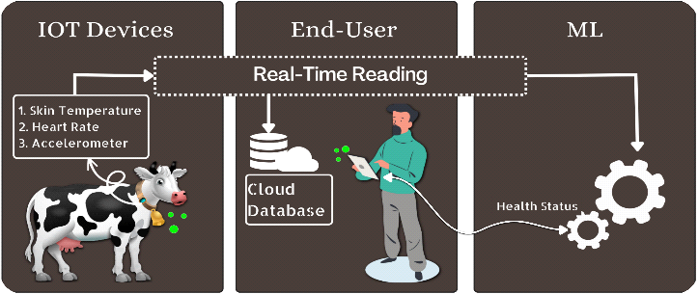

**Fig 1**. . Graphical representation of cattle health monitoring System

5. Farmer Engagement and Education: Implementing awareness campaigns, workshops, and incentives to promote sustainable health management practices.

6. Stakeholder Collaboration: Collaborating with veterinary services and farm management systems to ensure seamless integration and effective implementation.

7. Phased Rollout: Implementing the system in phases, starting with high-need areas, to ensure scalability and adaptability.

8. Continuous Monitoring and Evaluation: Regularly monitoring system performance, conducting health audits, and evaluating user feedback to identify areas for improvement.

9. Iterative Improvement: Using data insights and user feedback to refine the system, optimize health management processes, and enhance the overall user experience.

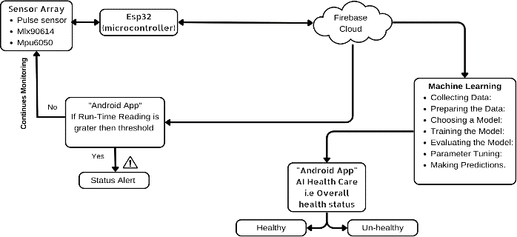

**Fig 2**. Block Diagram

**Artifacts used:**

**ESP32**

The low-cost, low-power ESP32 microcontrollers have dual-mode Bluetooth and built-in Wi-Fi. To

enable Wi-Fi and Bluetooth functionality, ESP32 can link to other devices via its SPI or I2C interfaces.

This project has the ability to function I2C protocol, as a master or a slave. a controller act as a server and sensors acts as a slave. The I2C pins by default are SDA: SDA (GPIO 21 by default), SCL: SCL (GPIO 22 by default),

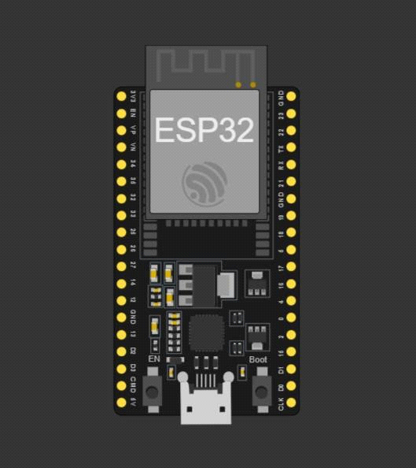

* **LCD Display:**
* Purpose:The LCD (Liquid Crystal Display) provides a visual interface for displaying information to users.
* Artifact:It typically consists of a display panel, backlighting, and a controller. In this project, an I2C LCD is used, which simplifies the wiring and communication with the microcontroller.

**Role in the Project:**

* The LCD displays information such as temperature, humidity, and the status of the waste bin (e.g., whether it's full or has space).

**MLX90614 :**

The MLX90614 is a powerful infrared sensor. Because it uses I2C communication, it can be attached to microcontrollers like the ES32 via I2C pins. according to Fig. 3. The SDA, SCL, GND, and VIN pins are the I2C pins, respectively. Factory calibrated in wide temperature range: -40 to 125.C for sensor temperature and -70 to

380.C for object temperature. High accuracy of 0.5.C over wide temperature range (0..+50.C for both Ta and To). The actual readings of body temperature were taken by code: int tempe = mlx.readObjectTempC();

and VCC: often 3.3V or 5V.

**MPU6050 :**

The 3-Axis gyroscope and 3-Axis accelerometer are both included on the MPU6050 chip. The X, Y, and Z axis rotational velocity and rate of change of angular position are measured by the gyroscope.

This sensor uses I2C communication and therefore it is connected to microcontrollers like ES32 through the I2C pins. The I2C pins are SDA, SCL, GND, and VIN pins respectively.

* Blynk App:
* Purpose:The Blynk app serves as the user interface for remote monitoring and control of the waste management system.
* Artifact:It is a mobile or web application that allows users to create custom dashboards, visualize data, and control IoT devices.
* Role in the Project:Users can view real-time data from the sensors, receive alerts when the bin is full, and remotely control certain functions of the system through the Blynk app.

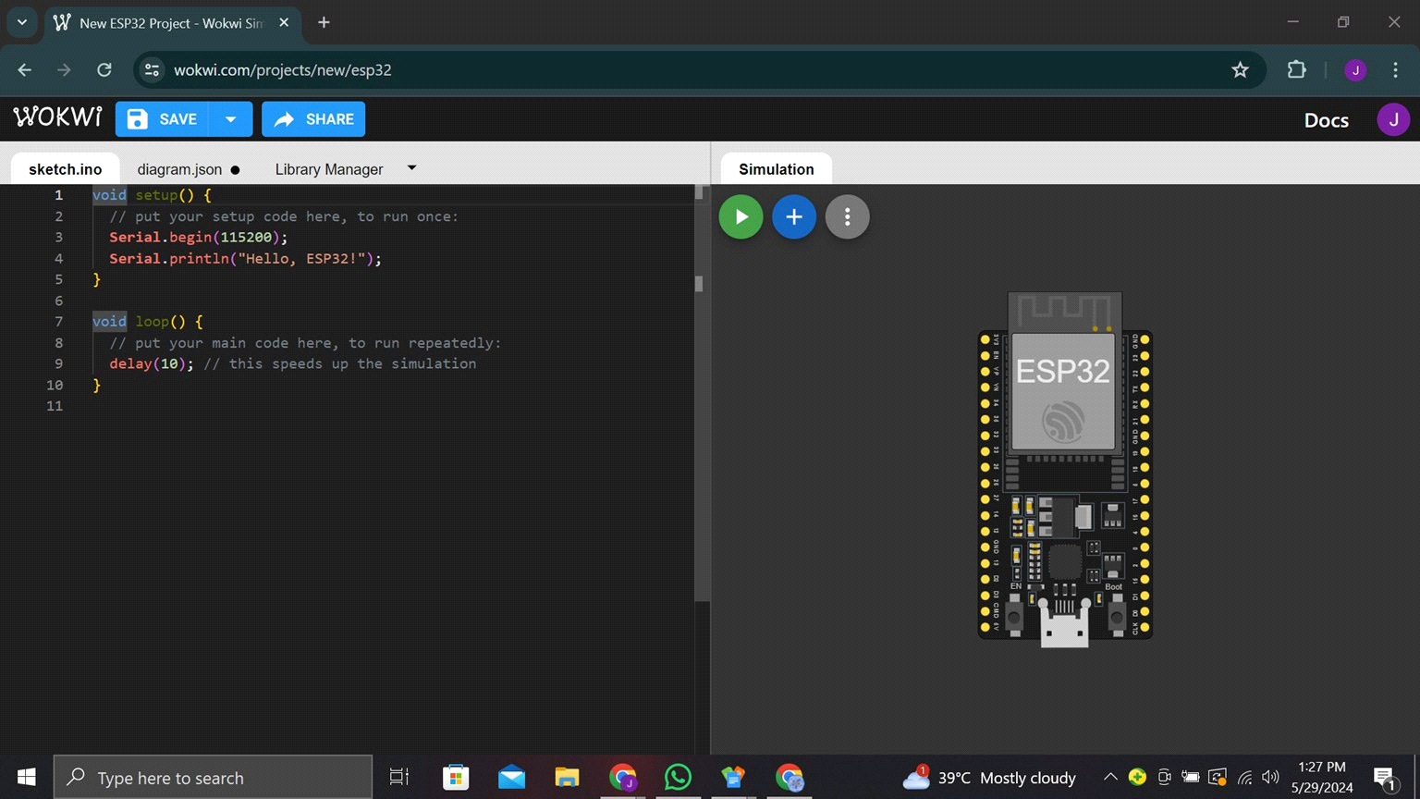

**Pulse Sensor:**

Pulse Sensor is the change in the volume of a blood vessel that occurs when the heart pumps blood and a detector that monitors this volume change.

As shown in Fig.3. pulse sensor is connected to ESP32 via Pin-1 (GND), Pin-2 (VCC), and Pin-3 (Signal). The actual readings of pulse rate were taken by code:

* int Pulse Sensor Purple Pin = 36;
* int percentage = (Pulse Sensor Purple Pin/4096) * 100;
* Note: 4096-channel analog-digital converter for pulse height analysis.

**Experiment Setup and Result**

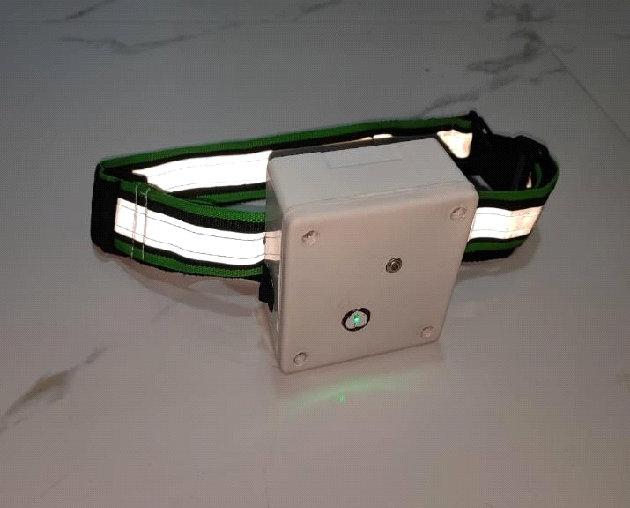

**Fig 4**. Smart Collar for Cattle

As shown in Fig 4, the whole model is created over a period of six months. finally, the smart collar with the reflective belt is ready for testing.

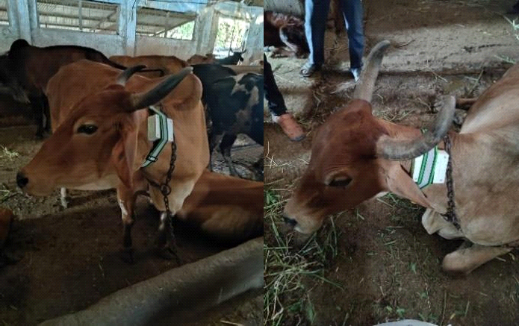

**Fig 5**. Experiments on cattle

As shown in Fig 5, two separate dairy cows were used to test this smart collar at the "Sheth Nathulal Trust Gaushala” in "Mumbai". Two-day trial on cattle was conducted in the afternoon and evening each day.

**Technical Coverage :**

The Cattle Health Care Management System includes:

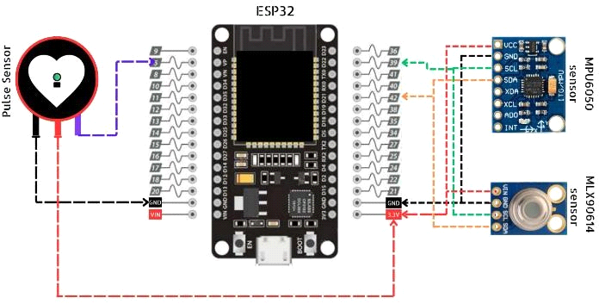

**Hardware:**

- IoT sensors (vital signs, activity levels, environmental conditions)

- Wearable devices for cattle

- GPS-enabled tracking for grazing management

**Software:**

- Data analytics platform (machine learning, predictive analytics)

- Mobile application (farmer engagement, reporting, education)

- Web portal (administration, monitoring, insights)

**Networking:**

- Wireless communication (Wi-Fi, cellular)

- Data transmission and storage (cloud-based)

**Data Management:**

- Data collection and processing

- Data visualization and insights

- Data security and privacy

**Integration:**

- Integration with existing farm management systems

- Collaboration with veterinary services and sustainability offices

**Security:**

- User authentication and authorization

- Data encryption and access control

**Scalability:**

- Modular system design

- Phased rollout and expansion

**Interoperability:**

- Compatibility with various devices and platforms

- Standardized data formats and APIs

**Benefits**

1. **Efficient Health Monitoring**:Optimizes health monitoring schedules, reducing unnecessary interventions and resource usage.
2. **Prevent Health Issues**: Detects early signs of health issues to prevent severe conditions and maintain cattle well-being.
3. **Resource Optimization:** Utilizes veterinary resources efficiently by targeting high-need areas.
4. **Remote Monitoring**: Enables users to monitor cattle health remotely for real-time updates and notifications.
5. **Data-Driven Decision Making:**Provides data insights for optimizing health management strategies and improving efficiency.
6. **Environmental Impact:** Contributes to reducing environmental impact by promoting sustainable livestock management practices.
7. **Cost-Effectiveness:**Reduces unnecessary veterinary visits and costs associated with treating preventable conditions.
8. **Sustainability**: Promotes sustainable health management practices by minimizing health issues and environmental impact.
9. **User Convenience:** Provides farmers with convenient access to cattle health status and management options through a mobile application.

Program:

#define BLYNK_AUTH_TOKEN "GGiaobnmFhfXKzeP-vBorMYmMrXcwLGT"

#define BLYNK_TEMPLATE_ID "TMPL3okV-M_VX"

#define BLYNK_TEMPLATE_NAME "cattle moniter"

#include <WiFi.h>

#include <Wire.h>

#include <LiquidCrystal.h>

#include <DHT.h>

#include <BlynkSimpleEsp32.h> // Include Blynk library for ESP32

#define DHTPIN 12

#define HR_PIN 32 // Heart Rate Potentiometer

#define SPO2_PIN 33 // SpO2 Potentiometer

#define PIR_PIN 25

#define DHTTYPE DHT22

DHT dht(DHTPIN, DHTTYPE);

const char auth[] = "GGiaobnmFhfXKzeP-vBorMYmMrXcwLGT";

const char *ssid = "Wokwi-GUEST";

const char *password ="";

BlynkTimer timer;

const int RS = 4, E = 15, DB4 = 5, DB5 = 18, DB6 = 19, DB7 = 21;

LiquidCrystal lcd(RS, E, DB4, DB5, DB6, DB7);

// Threshold values for abnormal states

const float TEMPERATURE_THRESHOLD = 40.0; // Celsius

const float HUMIDITY_THRESHOLD = 80.0; // Percentage

const int HEART_RATE_THRESHOLD = 120; // bpm

const int SPO2_THRESHOLD = 90; // Percentage

void sendSensorData() {

// Read sensor data

float temperature = dht.readTemperature();

float humidity = dht.readHumidity();

int pirStatus = digitalRead(PIR_PIN);

int heartRate = map(analogRead(HR_PIN), 0, 4095, 50, 150); // Assuming the heart rate range is from 50 to 150 bpm

int spo2 = map(analogRead(SPO2_PIN), 0, 4095, 70, 100); // Assuming the SpO2 range is from 70% to 100%

// Send sensor data to Blynk app

Blynk.virtualWrite(V5, temperature);

Blynk.virtualWrite(V6, humidity);

Blynk.virtualWrite(V7, pirStatus);

Blynk.virtualWrite(V8, heartRate);

Blynk.virtualWrite(V9, spo2);

// Check for abnormal states and trigger alert

if (temperature > TEMPERATURE_THRESHOLD || humidity > HUMIDITY_THRESHOLD ||

heartRate > HEART_RATE_THRESHOLD || spo2 < SPO2_THRESHOLD) {

triggerAlert();

}

}

void triggerAlert() {

// Read sensor data

float temperature = dht.readTemperature();

float humidity = dht.readHumidity();

int pirStatus = digitalRead(PIR_PIN);

int heartRate = map(analogRead(HR_PIN), 0, 4095, 50, 150); // Assuming the heart rate range is from 50 to 150 bpm

int spo2 = map(analogRead(SPO2_PIN), 0, 4095, 70, 100); // Assuming the SpO2 range is from 70% to 100%

// Print sensor data

Serial.println("Cattle in abnormal state! Alert!");

Serial.print("Temperature: ");

Serial.print(temperature);

Serial.println(" °C");

Serial.print("Humidity: ");

Serial.print(humidity);

Serial.println("%");

Serial.print("Heart Rate: ");

Serial.println(heartRate);

Serial.print("SpO2: ");

Serial.println(spo2);

Serial.print("PIR Status: ");

Serial.println(pirStatus);

}

void setup() {

Serial.begin(115200);

dht.begin();

lcd.begin(16, 2);

pinMode(HR_PIN, INPUT);

pinMode(SPO2_PIN, INPUT);

pinMode(PIR_PIN, INPUT);

connectWiFi(); // Connect to WiFi and start Blynk

}

void loop() {

sendSensorData(); // Read sensor data and send to Blynk

Blynk.run();

timer.run();

delay(2000);

}

void connectWiFi() {

Serial.println("Connecting to WiFi");

WiFi.begin(ssid, password);

while (WiFi.status() != WL_CONNECTED) {

delay(1000);

Serial.println("Connecting...");

}

Serial.println("Connected to WiFi");

Blynk.config(BLYNK_AUTH_TOKEN);

timer.setInterval(1000L, sendSensorData);

}

void display(float temp, float hum, int hr, int spo2, int pir) {

lcd.clear();

lcd.setCursor(0, 0);

lcd.print("T:");

lcd.print(temp);

lcd.print("C H:");

lcd.print(hum);

lcd.print("%");

lcd.setCursor(0, 1);

lcd.print("HR:");

lcd.print(hr);

lcd.print(" SpO2:");

lcd.print(spo2);

lcd.print("% ");

lcd.print("PIR:");

lcd.print(pir);

}

Output:

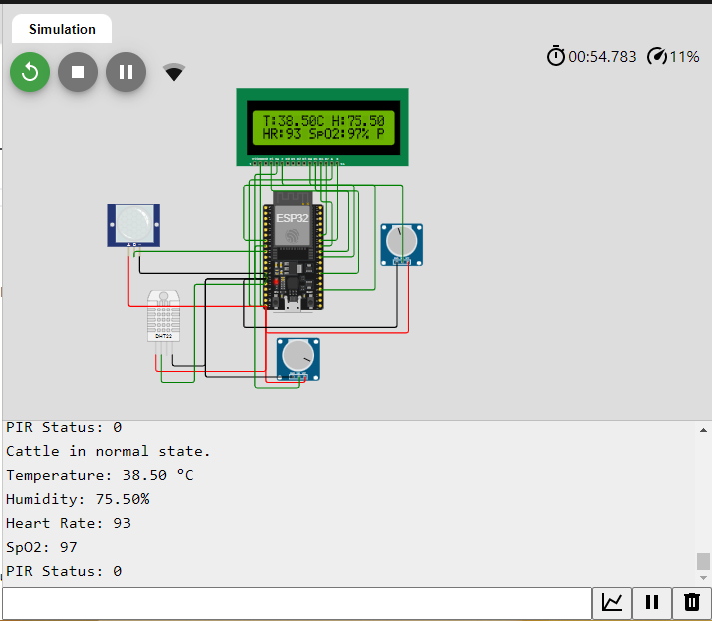

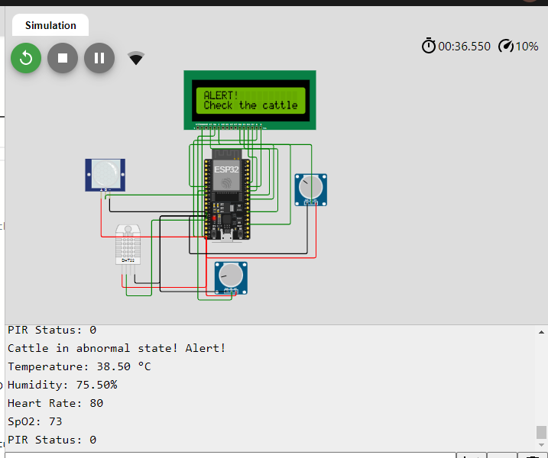

Blynk Database Output :

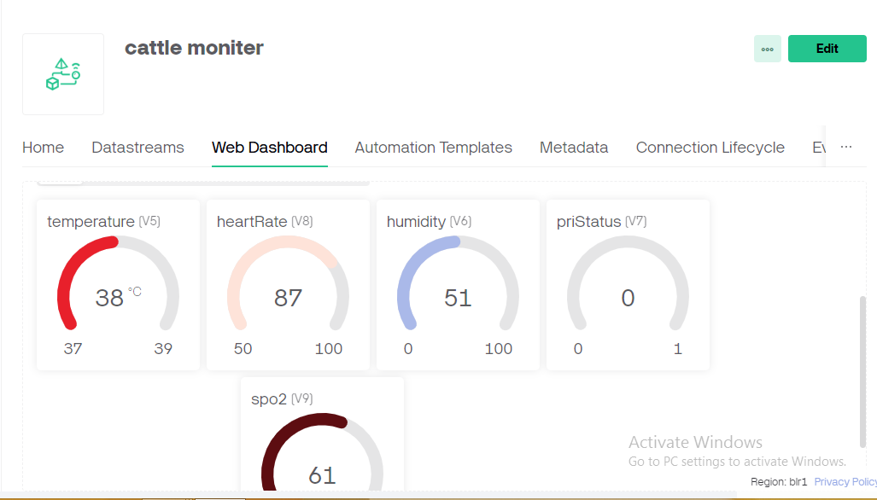

Result:

**Overview: Cattle Health Care Monitoring System**

The Cattle Health Care Monitoring System has been successfully developed to provide a robust and user-friendly solution for monitoring the health and well-being of cattle. This system continuously tracks vital health metrics, allowing farmers and veterinarians to access real-time data and manage cattle health remotely via a mobile app.

**Key Features:**

Real-Time Monitoring: Users can monitor vital signs such as temperature, heart rate, and activity levels of cattle in real-time through the Blynk app.

Automated Alerts: The system sends automatic alerts when abnormal health metrics are detected, ensuring timely intervention.

Remote Control: Users can control various system features, such as activating alarms or adjusting monitoring settings, through the Blynk app from anywhere on the farm.

**Technical Performance:**

Hardware Integration: The system integrates the ESP32 microcontroller, temperature sensors, heart rate sensors, motion detectors, and alert systems to ensure accurate data collection and transmission.

**Software Development:**

The ESP32 is programmed to efficiently process sensor data and communicate with the Blynk cloud using the Arduino IDE and Blynk library.

**Data Transmission:**

The system reliably transmits sensor data to the Blynk platform at regular intervals, providing continuous updates for health monitoring.

**User Experience**

**Convenience:**

Farmers can easily monitor the health status of their cattle from their mobile devices, enhancing farm management efficiency.

**Timely Alerts**:

Automated alerts ensure that users are promptly informed of any health issues, facilitating early diagnosis and treatment .

**Remote Control:**

The ability to remotely control system features adds flexibility and convenience, allowing for efficient health management and timely responses to emergencies.

**Results Achieved**

**Improved Health Monitoring Accuracy:**

The system provides accurate real-time health data, enabling data-driven decisions and timely interventions.

**Enhanced Animal Welfare:**

Continuous health monitoring has led to improved animal welfare by ensuring timely medical attention.

**Increased Productivity:**

Healthier cattle contribute to increased productivity and profitability on farms.

**Reduced Veterinary Costs:**

Early detection of health issues reduces the need for extensive veterinary treatments, cutting down on costs.

**High User Engagement:**

The mobile application and alert system have encouraged active participation in cattle health management practices.

**Challenges and Resolutions :**

**Sensor Accuracy and Calibration:**

Ensuring accurate readings from various health sensors required regular calibration and verification against known health metrics.

**WiFi Connectivity and Stability:**

Maintaining stable WiFi connections for continuous data transmission was addressed by implementing network optimization strategies and robust reconnect logic.

**Power Management:**

Effective power consumption management was achieved by optimizing code for power efficiency and using deep sleep modes for the ESP32 during idle periods.

**User Interface and Experience:**

Creating an intuitive and user-friendly interface on the Blynk app was achieved through iterative improvements based on user feedback and comprehensive documentation.

**Environmental Interference:**

Mitigating environmental interference with sensor readings was managed by strategically placing sensors and using protective enclosures.

**Conclusion:**

The Cattle Health Care Monitoring System demonstrates how technology-driven solutions can transform livestock management. By leveraging IoT sensors, data analytics, and mobile applications, the system optimizes health monitoring, reduces costs, and improves animal welfare. The real-time data insights, user engagement, and stakeholder collaboration are key to its success. The system's scalable and adaptable design ensures it can meet the evolving needs of farms. Continuous monitoring and iterative improvements have optimized health management processes, making the system a model for other agricultural applications. This project underscores the potential for technology to enhance the sustainability and efficiency of livestock farming.

**References :**

1) Accuweather.com, 2023, https://www.accuweather.com/en/in/mumbai/204842/march-weather/ 204842? year=2023

2) Becker C.A., R.J. Collier, A.E. Stone 2020, Invited review: Physiological and behavioral effects of heat stress in dairy cows, Journal of Dairy Science, 103,(8): 6751-6770, <https://doi.org/10.3168/jds.2019-17929>.

3) Chatterjee J, Pinaki & Ray, Niranjan & Mohanty, Saraju. 2021. LiveCare: An IoT-Based Healthcare Framework for Livestock in Smart Agriculture. IEEE Transactions on Consumer Electronics. PP. 1-1. 10.1109/TCE.2021.3128236.

4) Chaudhry A., R. Mumtaz, S. M. Hassan Zaidi, M. A. Tahir and S. H. Muzammil School, "Internet of Things (IoT) and Machine Learning (ML) enabled Livestock Monitoring," 2020. IEEE 17th International Conference on Smart Communities: Improving Quality of Life Using ICT, IoT and AI (HONET), Charlotte, NC, USA, 2020, pp. 151-155, doi: 10.1109/HONET50430.2020.9322666.

5) Dutta D., D Natta, S Mandal, N Ghosh, MOOnitor: An IoT based multi-sensory intelligent device for cattle activity monitoring, Sensors, and Actuators A:Physical, Volume 333, 2022,113271, ISSN0944247,https://doi.org/10.1016/j.sna.2021.113271.

6) Farooq M.S., O. O. Sohail, A. Abid, and S. Rasheed 2022. , "A Survey on the Role of IoT in Agriculture for the Implementation of Smart Livestock Environment," in IEEE Access, vol. 10, pp. 9483-9505, 2022, doi: 10.1109/ACCESS.2022.3142848.

7) Farooq M.S., O. O. Sohail, A. Abid, and S. Rasheed 2022. , "A Survey on the Role of IoT in Agriculture for the Implementation of Smart Livestock Environment," in IEEE Access, vol. 10, pp. 9483-9505, 2022, doi: 10.1109/ACCESS.2022.3142848.

8) Faruq, I. Syarif, A.S. Ahsan, M. Udin Harun Al Rasyid and Y. P. Pratama, 2019. "Health Monitoring and Early Diseases Detection on Dairy Cow Based on Internet of Things and Intelligent System," 2019 International Electronics Symposium (IES), Surabaya, Indonesia, 2019, pp. 183-188, doi: 10.1109/ELECSYM.2019.8901527.

9) Habeeb AA, Gad AE, Atta MA. 2018. Temperature-Humidity Indices as Indicators to Heat Stress of Climatic Conditions with Relation to Production and Reproduction of Farm Animals. Int J Biotechnol Recent Adv. 2018; 1(1): 35-50. doi: 10.18689/ijbr-1000107

10) Nootyaskool, S. and P. Ounsrimung, "Smart Collar Design to Predict Cow Behavior," 2020 17th International Joint Conference on Computer Science and Software Engineering (JCSSE), Bangkok, Thailand, 2020, pp. 92-97, doi: 10.1109/JCSSE49651.2020.9268342.

11) Pratama Y.P. et al., "Designing of a Smart Collar for Dairy Cow Behavior Monitoring with Application Monitoring in Microservices and Internet of Things-Based Systems," 2019 International Electronics Symposium (IES), Surabaya, Indonesia, 2019, pp. 527-533, doi: 10.1109/ELECSYM.2019.8901676